Consider an ant crawling along the edges of a cube. The ant traverses a single edge in one second, and the ant only changes direction at a corner at which point it randomly selects from the three possible directions. Given these facts, what is the mean time taken by the ant to traverse the cube from the starting corner to the opposite corner? One such path, taking three seconds, is illustrated below.

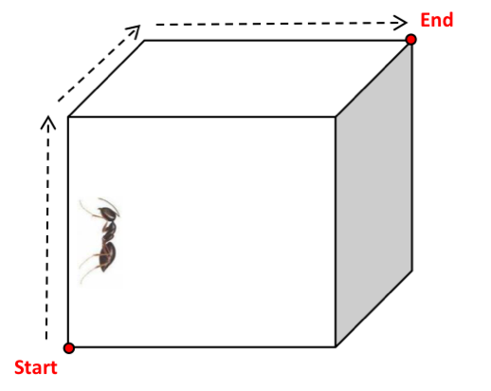

Your task is to write a program to investigate this problem using simulation with the following features:

- A working application with a simple UI and source code in Scala or Java.
- Accurate, fast, well written and clearly structured solution.
- Use of caching techniques where applicable.
- The program should be capable of using multiple cores.
- Besides the mean time, any additional statistical information will be a plus.
- We would also like to know how you verified the results.

